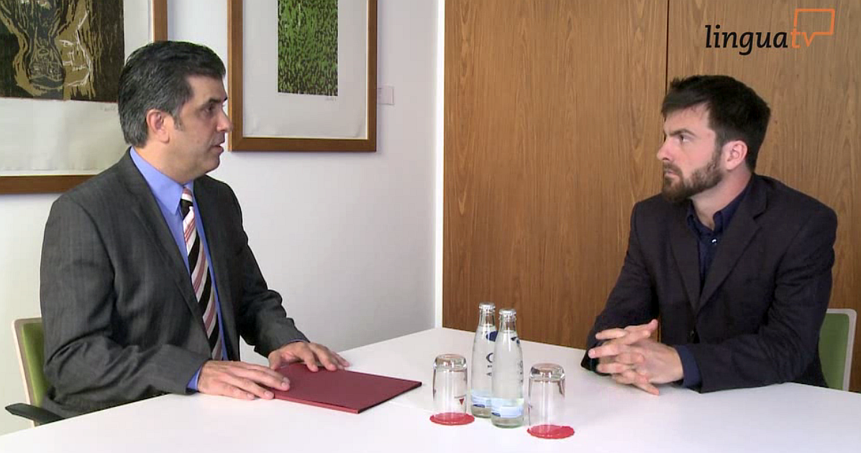

**Video Comprehension: The job interview**

You will watch Paul Smithers, who is having a job interview at the

IT company *Ostico*, while he is being interviewed by Glen Smith.

Work on the following tasks while watching the video.

1. How is the job interview started?

2. What position is Paul Smithers applying for?

3. How many people would he be responsible for?

4. Why was he invited to the interview?

5. Where did he study informatics?

6. What information do we get about his work experience in the U.S.?

|  |  |  |  |
| --- | --- | --- | --- |
| **City:** |  | **Duration:** |  |
| **Job role:** |  | | |
| **Information on**  **Company:** |  | | |

7. Additional work experience?

|  |  |  |  |
| --- | --- | --- | --- |
| **City:** |  | **Duration:** |  |
| **Type of company:** |  | | |

8. What skills does he mention?

9. What is his greatest strength / weakness:

10. What do we get to know about Ostico?

|  |  |  |  |
| --- | --- | --- | --- |
| **Founded in:** |  | **Employees:** |  |
| **Serving customers in:** |  | **Specialising in:** |  |

11. Why would Paul Smithers be the perfect candidate?

12. When will he receive an answer to his application?

13. What can you say about Paul Smithers‘ confidence (body language)?

Further Questions:

a. What other questions could Mr. Smith have asked?

b. What other questions should Paul Smithers have asked?

[Source: Klett (2014): Business to Business. Englische Geschäftskorrespondenz und Bürokommunikation, p.311]



After you have been invited to an interview:

Do some research. Find out as much as you can about the company, its products or services and the image it projects so that you make an informed impression and demonstrate that you are really interested in the company. How old is the company? Has the company been mentioned in the press recently? Does the Internet provide any information?

This will enable you to ask intelligent questions. Also, think beforehand of any questions about the position you would like to ask if they are not covered by the interviewer, e. g. exact location, type of work, starting salary, opportunities for further training, salary, opportunities to use your language skills, benefits, catering arrangements, etc. How big is the office you will be working in? Will you have contact with the customers (front office) or is it a back office? Make a check list.

Be prepared for any embarrassing questions the interviewer might ask. Are there any gaps in your CV or poor grades in exams? What are your reasons for wanting to change jobs? Consider beforehand what your reply would be - many interviewers will ask a slightly more difficult/delicate question to see how you cope with it!

What are your other interests? Think carefully about this. If you say you enjoy relaxing with a book, expect to be asked what sort of books you read or what the last book you read was. Rehearse this in front of the bathroom mirror! If you are not prepared or able to talk about an interest, do not mention it in your CV.

Finally, do not underestimate the importance of so-called "soft skills" - a neat, clean appearance, shirt tucked into trousers, polished shoes with laces tied, hair neatly cut and combed, etc. Women should usually go for a skirt (not trousers in Britain) and jacket top with a discreet amount of jewellery at most. Don't whatever you do risk wearing jeans and a T-shirt. Men should wear a business suit, conservative tie, dark socks (Britain).

The following is a list of negative factors in an interview as evaluated by employers:

* poor personal appearance
* overbearing - too aggressive - conceited -"superiority complex" - "know it all"
* inability to express thought clearly - poor diction or grammar
* lack of planning for career - no purpose or goals
* lack of interest and enthusiasm - passive, indifferent
* lack of confidence - nervousness
* over-emphasis on money
* lack of tact - maturity - courtesy
* condemnation of past employers
* failure to look interviewer in the eye
* limp, fishy handshake
* lack of appreciation for the value of experience
* failure to ask questions about the job
* persistent attitude of "What can you do for me?"
* lack of preparation for the interview - inability to ask intelligent questions